ARGUELLES MILITARY BIO FORM

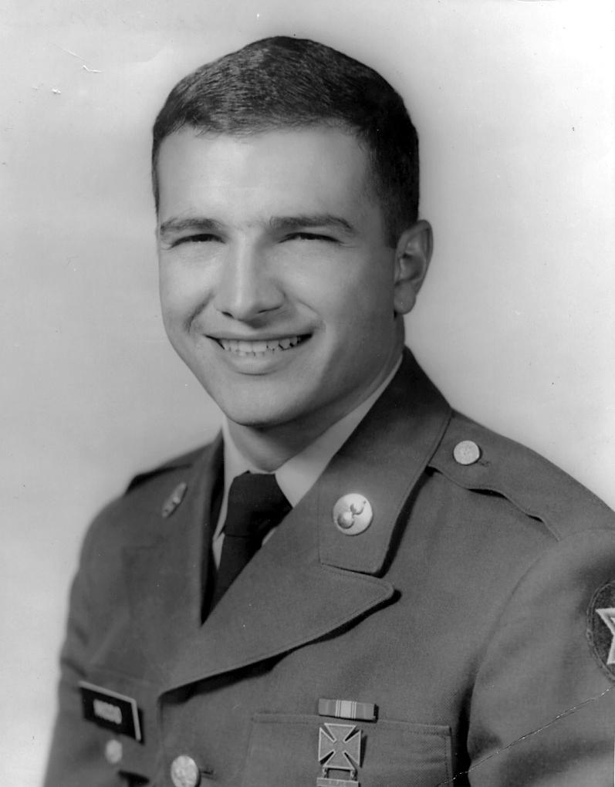
Name: Edward F. Miccio
Date of Birth: 10/02/1944
Service Branch: US Army
Rank: Specialist 5th Class
Date Entered Service: September 1966
Date Discharged: September 1969
Conflict/Timeframe Served: Vietnam
Military Occupational Specialty (MOS):
- Small Arms Repairman
- Small Missile System Repairman
- Nike Hercules Missile System Repairman
Current Residence: Westminster, Colorado
Email Address: ed.miccio@comcast.net

